GROUP TWO MEMBERS

1. Adrianna Bitutu -134126
2. Clarice Muthoni -127707
3. Alvin Maina -130834
4. Charity Makhanu -124534
5. Diana Koigi- 122523

**The Railway Reservation Case Study.**

1. **Identify possible actors in the case study.**
2. Passengers.
3. Admin**.**
4. **Identify possible classes in the case study.**
5. Ticket.
6. Train.
7. Train Status.
8. Passenger.
9. Database.
10. Train Record.
11. **Draw a Use Case Diagram for the Railway Reservation System.**

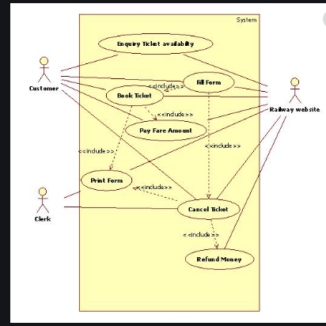

1. **Draw a Class Diagram for the Railway Reservation System.**
2. **Draw a System Sequence Diagram for the Railway Reservation System.**